

SCHOOL OF COMPUTER SCIENCE AND INFORMATION TECHNOLOGY

A COURSE BASED REPORT (IOT)
ON
“Arduino Rain Water Alarm”
Submitted in fulfillment of the requirements for the award of the Degree of

BACHELOR OF TECHNOLOGY
IN
COMPUTER SCIENCE AND ENGINEERING
(Artificial Intelligence and Machine Learning)

Submitted by

Deekshitha G R (R24EA026)
Harshitha H M (R24EA049)
Poojitha M (R24EA102)
Yai Hansika (R24EA174)

Under the guidance of
Dr. Sankar Prasad Bag
Associate Professor School of ECE
REVA University

January 2025
Rukmini Knowledge Park, Kattigenahalli, Yelahanka, Bengaluru-560064
www.reva.edu.in

DECLARATION

We, Deekshitha G R(R24EA026) etc… students of B.Tech, belongs to School of Computer Science Engineering REVA University, declare that this IOT Report “Arduino Rain Water Alarm” is the result of work done by us under the supervision of Dr. Sankar Prasad Bag Associate Professor School of ECE REVA University, Bengaluru.

We are submitting this Report in partial fulfillment of the requirements for the completion of Course in IOT and Applications in I-Semester of Bachelor of Technology in Computer Science and Engineering(AIML) by the REVA University, Bengaluru during the academic year 2024-2025.

(Signature of the Students)

January 2025

Certified that this work submitted by Deekshitha G R(R24EA026) etc …. has been carried out under our guidance and the declaration made by the candidates is true to the best of our knowledge.

Signature of Faculty Signature of Director
Date: January 2025 Date: January 2025
Official Seal of the School

Name of the Examiner with affiliation Signature with Date
1.
2.
List of Contents |  | Page No.
List of Figures and Tables
Abstract
Chapter-I | 1.1 Introduction
Chapter-I | 1.2 Objectives
Chapter-I | 1.3 Layout
Chapter-II | 2.1 Literature Survey
Chapter-II | 2.2 Comparison Table
Chapter-III | 3.1 Methodology of Work
Chapter-III | 3.2 Results and Analysis
Chapter-IV | 4.1 Conclusion
Chapter-IV | 4.2 Future Scope
References
Program

ABSTRACT
The Arduino Rain Alarm is a sensor-based project aimed at detecting and alterting users to the presence of rain.Utilizing Arduino technology and rain sensors,this system efficiently monitors environmental conditions.When rainfall is detected the alarm activates providing a practical solution for early warning in diverse settings,includind home environments and agricultural applications.With its adaptability and cost effectiveness,this project contributes to efficient water management and serves as a customizable tool for enhancing weather-aware systems

The Rain Alarm project aims to design and develop an efficient system that alerts users about impending rainfall to prevent inconvenience and damage caused by unexpected weather changes. This project integrates a rain sensor, microcontroller, and alarm system to detect rainfall in real-time. When raindrops are detected by the sensor, the system triggers an audio or visual alert to notify users immediately.

The Rain Alarm system is designed for a variety of applications, such as protecting outdoor laundry, preventing water damage to open vehicles or machinery, and assisting farmers in monitoring rain conditions in agricultural fields. The system is energy-efficient, cost-effective, and user-friendly, making it accessible for both urban and rural settings. By providing timely warnings, this project enhances convenience and promotes proactive measures against weather challenges.

Chapter-I
Introduction
  - Introduction
Arduino Rain Water involve the integration of Arduino microcontroller with rain sensors to monitor and respond to precipitation.These projects address a range of applications,from simple rain detection for home use to more sophisticated systems for agriculture or environmental monitoring.By leveraging Arduino’s versatility,enthusiasts and professionals alike can create customized solutions for water management,early warning systems,and data collection.The integration of technology in rainwater related projects not only enhances efficiency but also contributes to sustainable practices and resource conservation
A rain alarm is an innovative device designed to alert individuals about impending rain. It typically uses sensors to detect changes in weather conditions, such as increased humidity, drops in atmospheric pressure, or the presence of rain droplets. Once these conditions are identified, the alarm notifies users through sounds, lights, or mobile app notifications, enabling them to take preventive measures, such as carrying an umbrella or protecting outdoor items. Rain alarms are particularly useful for farmers, commuters, and outdoor enthusiasts who need timely information to avoid disruptions caused by unexpected rain.
1.2 Objectives
The objectives of a rain alarm include:
1.Early Rain Detection: To alert users about the onset of rain in advance, allowing them to prepare accordingly.
2. Weather Awareness: To increase awareness of sudden weather changes, especially for individuals who spend significant time outdoors.
3. Convenience: To eliminate the need for constant weather monitoring by providing timely alerts automatically.
4. Damage Prevention: To help protect outdoor belongings, such as clothes, tools, or electronics, from getting wet.
5. Agricultural Support: To aid farmers in making informed decisions about irrigation, crop protection, and other farming activities.
6. Enhanced Mobility: To assist commuters and travelers in planning their routes and carrying rain protection gear.
7. Energy Efficiency: To integrate with automated systems, such as closing windows or activating waterproof covers, for greater efficiency.
1.3 Layout

TRANSFORMER
RECTIFIER
REGULATOR
COMPARATOR
RAIN SENSOR
RELAY
SIREN

Chapter–II
Review on Existing Literature
2.1 Literature Survey
A literature on an Arduino rainwater alarm would involve researching existing works related to rainwater detection using Arduino. Look for academic papers, articles, and projects that discuss the design, implementation and performance of rainwater alarms with Arduino. Consider factors like sensor types, data processing, and alarm triggering mechanisms. This will help you understand the current state of the field and identify gaps or areas for improvement in rainwater alarm systems.
Investigate literature on rainwater harvesting sysyte4ms, including technological aspects and monitoring components. Explore studies related to environmental monitoring using IoT devices, as Arduino is often used in such applications. Search for researches that discusses the use of Arduino in water-related projects, including alarms and sensor applications. Look for literature on sensor technologies specifically designed for rain detection and water presence sensing. Explore studies on smart water systems, which may include components like rain sensors and alarms. Investigate community-based or open-source environmental projects that might involve rainwater alarms and Arduino. Explore literature on sustainable water practices, as rainwater harvesting and monitoring align with sustainability goals.
2.2 Arduino UNO
Arduino UNO is a popular open-sourced micro controller developed by Arduino.cc. It’s based on the ATmega328P micro-controller, which is part of the AVR family. The ATmega328Poperates at 15MHz, providing processor power for a variety of applications. It is equipped with a micro-controller, 14 digital input/output pins (of which 6 can be used as PWM outputs), 6 analog input pins (labeled A0 to A5) (These pins can measure analog voltages (usually between 0V and 5V)). The board is powers and programmed through a USB connection, making it easy to interface with a computer.

2.3 Comparison Table
Feature | Arduino Uno in Rain Alarm System
Author Name | Open-source community, primarily by Massimo Banzi and David Cuartielles.
Application Method | Used for creating custom alarm systems, including sensors for motion, temperature, etc.
Rain Threshold | Customizable based on rain sensor input (e.g., YL-83 Rain Sensor)
Equilateral | N/A (Equilateral generally refers to geometry, not relevant to this context)
Machine Learning | Not inherently part of Arduino Uno; machine learning can be implemented with additional components (e.g., TensorFlow Lite)
Data Validation | Can be programmed to validate sensor data through threshold checks, error detection, and filtering
Communication | Supports serial communication (USB), I2C, and SPI for connecting to other devices or modules (e.g., Wi-Fi, Bluetooth)
Voltage | Operates at 5V with a recommended input voltage range of 7-12V.
Controller | Microcontroller: ATmega328P

Chapter-III
Work, Results and Analysis
3.1 Work
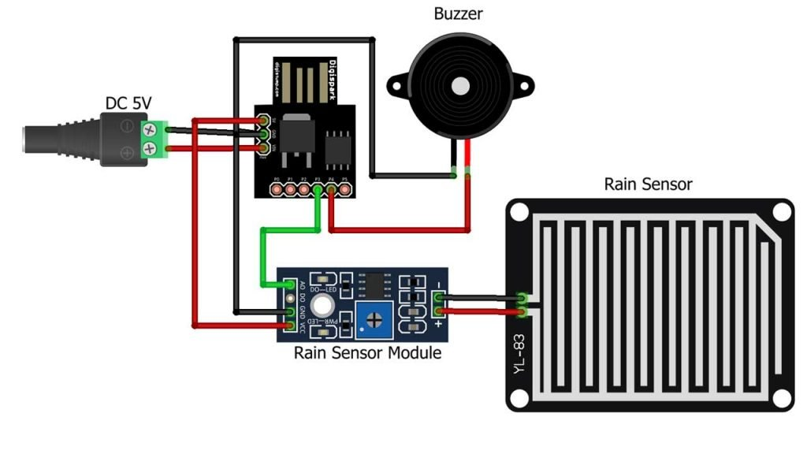
3.2 Results

Arduino components are relatively affordable,making it a cost-effective option for a rainwater alarm system .Arduino allows for easy customization of the rainwater alarm based on specific needs.Users can modify the code and hardware to suit their requirements,Arudino uses a simple programming language,making it accessible for beginners.Programming the rain water alarm can be done with basic coding skills,Arduino has a large and active community,providing access to forums,tutorials,and shared projects
Analysis of Rain Alarm Systems
A rain alarm is a device or system that detects rainfall and provides an alert. It is commonly used for agricultural purposes, outdoor event management, and personal safety. Below is an analysis of its working, components, advantages, and limitations.

1. Working Principle
A rain alarm operates based on the detection of water droplets. When rainwater comes into Scontact with the sensor, it completes an electrical circuit, triggering an alert (such as a buzzer or notification).

2. Components
- Rain Sensor: Detects water presence (e.g., using conductive plates or a hygroscopic material).
- Microcontroller (optional): Processes sensor data and activates alarms.
- Buzzer or Speaker: Generates an audible alarm when rain is detected.
- Display or LED Indicator (optional): Provides a visual warning.
- Power Source: Typically a battery or direct power supply.

3. Applications
- Agriculture: Helps farmers take preventive measures for crops and irrigation systems.
- Construction: Alerts workers to protect materials from rain damage.
- Outdoor Events: Provides early warning to manage weather-sensitive activities.
- Smart Homes: Can be integrated with automated windows and roofing systems.

Chapter-IV: Conclusion & Future Scope
4.1 Conclusion
In conclusion, an Arduino rainwater alarm system offers a simple yet effective solution for detecting and responding to rain conditions. This type of system is particularly useful in various applications, including home automation, gardening, and environmental monitoring. Here are key points to summarize the benefits and considerations of an Arduino rainwater alarm.

As technology advances; future developments in Arduino rainwater alarms may include enhanced sensor technologies, improved energy efficiency, and integration with smart home ecosystems, Additionally, community-driven projects and open-source contribution may lead to innovations and expanded functionalities.
Arduino rainwater alarms provide an accessible and customizable solution for individuals interested in monitoring and responding to rain conditions. The simplicity, affordability, and adaptability of Arduino platforms make them well-suited for a wide.

4.2 Future Scope
The future scope for Arduino rainwater alarm systems is promising, and potential developments could focus on improving functionality, efficiency, and integration. Here are some future directions and areas of exploration. Integration of advanced rain sensor technologies to improve accuracy, sensitivity and reliability in rain detection. This may include the use of capacitive sensors, acoustic sensors, or more sophisticated optical sensors. Enhancing connectivity by integrating Arduino rainwater alarms with Internet of Things (IoT) platforms. This could enable remote monitoring, data logging and real time alerts through cloud-based services. Implementing machine learning algorithms to analyse historical rain patterns and optimise threshold values dynamically. This could improve the system’s adaptability to changing environmental conditions, range of applications in water management and environmental sensing.

References

- https://circuitdigest.com/microcontroller-projects/rain-detector-using-arduino.
- https://arduinopoint.com/rain-sensor-arduino-project/
3. How does a rain sensor work and how to interface with Arduino?
https://circuitdigest.com/microcontroller-projects/interfacing-rain-sensor-with-arduino.
4. Rain detector using Arduino and raindrop sensor – Techatronic
https://techatronic.com/rain-detector-using -arduino-and-raindrop-sensor/
5. Rain drop sensor with Arduino, Rain Detector Arduino code.
https://www.electroniclinic.com/rain-drop-sensor-with-arduino-rain-detector-arduino- code-circuit/
6. Rain detector using Arduino, HL-83 Rain sensor and buzzer.
https://electronicsprojects.in/rain-detector-using-arduino-83-rain-sensor-and-buzzer/

Program
int rainsense=A0;
int buzzerout=10;
int countval=0;
int ledout=11;
void setup()
{
Serial.begin(9600);
pinMode(buzzerout,OUTPUT);
pinMode(ledout,OUTPUT);
pinMode(rainsense,INPUT);

}
void loop()
{
int rainSenseReading=analogRead(rainsense);
Serial.println(rainSenseReading);
delay(250);
if(countval>=35)
{
Serial.print("Heavy Rain");
digitalWrite(buzzerout,HIGH);
digitalWrite(ledout,HIGH);
}
if(rainSenseReading<500){
countval++;
}
else if(rainSenseReading>500)
{
digitalWrite(buzzerout,LOW);
digitalWrite(ledout,LOW);
countval=0;

}
delay(1000);

}

